$$y_{i}=β_{0}+\sum_{j=1}^{k}{β_{j}x_{ij}+ε_{i}}, i=1, 2, …, n$$

$$y=Xβ+ε$$

where:

$$\begin{matrix}y=\left[\begin{matrix}y_{1} \\ y_{2} \\ ⋮ \\ y_{n}\end{matrix}\right] & X=\left[\begin{matrix}1 & x_{11} & x_{12} & ⋯ & x_{1k} \\ 1 & x_{21} & x_{22} & ⋯ & x_{2k} \\ ⋮ & ⋮ & ⋮ & ⋮ & ⋮ \\ 1 & x_{n1} & x_{n2} & ⋯ & x_{nk}\end{matrix}\right] \\ β=\left[\begin{matrix}β_{0} \\ β_{1} \\ ⋮ \\ β_{k}\end{matrix}\right] & ε=\left[\begin{matrix}ε_{1} \\ ε_{2} \\ ⋮ \\ ε_{n}\end{matrix}\right]\end{matrix}$$

$$S\left(β\right)=\sum_{i=1}^{n}{ε_{i}^{2}}=ε^{'}ε={\left(y-Xβ\right)}^{'}\left(y-Xβ\right)=y^{'}y-y^{'}Xβ-β^{'}X^{'}y+{β^{'}X}^{'}Xβ$$

Since $β^{'}X^{'}y$ is a scalar and ${\left(β^{'}X^{'}y\right)}^{'}=y'Xβ$ is the same scalar:

$$S\left(β\right)=y^{'}y-2β^{'}X^{'}y+{β^{'}X}^{'}Xβ$$

if:

$${\left.\frac{δS}{δβ}\right|}_{\hat{β}}=-2X^{'}y+2X^{'}X\hat{β}=0$$

then:

$$X^{'}X\hat{β}=X'y$$

$$\hat{β}={(X^{'}X)}^{-1}X'y$$

$$\hat{y}=X\hat{β}=X{\left(X^{'}X\right)}^{-1}X^{'}y=Hy$$

$$Var\left(\hat{y}\right)=Var(Hy)$$

Since $Var\left(AZ\right)=AVar\left(Z\right)A'$ when A is a constant matrix and **Z** is a random vector:

$$Var\left(\hat{y}\right)=HVar\left(y\right)H^{'}$$

$$Var\left(\hat{y}\right)=H\left(σ^{2}I\right)H^{'}$$

Since **H** is symmetric:

$$Var\left(\hat{y}\right)=H\left(σ^{2}I\right)H=σ^{2}HIH=σ^{2}HH=σ^{2}H^{2}$$

Since **H** is Idempotent:

$$Var\left(\hat{y}\right)=σ^{2}H$$

1. Symmetric **H**

$$H=X{\left(X^{'}X\right)}^{-1}X^{'}$$

$$H^{'}={\left[X{\left(X^{'}X\right)}^{-1}X^{'}\right]}^{'}$$

$$H^{'}=X{\left[{\left(X^{'}X\right)}^{-1}\right]}^{'}X^{'}$$

$$H^{'}=X{\left[{\left(X^{'}X\right)}^{'}\right]}^{-1}X^{'}$$

$$H^{'}=X{\left(X^{'}X\right)}^{-1}X^{'}$$

$$H^{'}=H$$

Idempotent **H**

$$H^{2}=\left[X{\left(X^{'}X\right)}^{-1}X^{'}\right]\left[X{\left(X^{'}X\right)}^{-1}X^{'}\right]$$

$$H^{2}=X{\left(X^{'}X\right)}^{-1}(X^{'}X){\left(X^{'}X\right)}^{-1}X'$$

Since $A^{-1}A=I$:

$$H^{2}=XI{\left(X^{'}X\right)}^{-1}X^{'}=X{\left(X^{'}X\right)}^{-1}X^{'}$$

$$H^{2}=H$$

Symmetric **I-H**

$${\left(I-H\right)}^{'}=I^{'}-H'$$

Since **I** is symmetric and **H** is symmetric:

$${\left(I-H\right)}^{'}=I-H$$

Idempotent **I-H**

$${(I-H)}^{2}=I^{2}-2IH+H^{2}$$

Since **I** is idempotent and **H** is idempotent:

$${\left(I-H\right)}^{2}=I-2H+H$$

$${(I-H)}^{2}=I-H$$

$$e_{i}=y_{i}-{\hat{y}}_{i}$$

$$e=y-\hat{y}$$

$$e=y-Hy$$

$$e=\left(I-H\right)y$$

$$E\left(e\right)=E[\left(I-H\right)y]$$

Since **I-H** is a constant matrix:

$$E\left(e\right)=\left(I-H\right)E\left(y\right)=\left(I-H\right)\left(Xβ\right)$$

$$E\left(e\right)=Xβ-HXβ$$

$$E\left(e\right)=0$$

$$Var\left(e\right)=Var[\left(I-H\right)y]$$

Since $Var\left(AZ\right)=AVar\left(Z\right)A'$ when A is a constant matrix and **Z** is a random vector:

1. 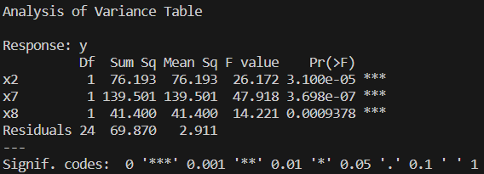



Based on the p-value of the F-statistic being <0.05, we can reject the null hypothesis and conclude that at least one of the regressors contributes significantly to the model.

1. 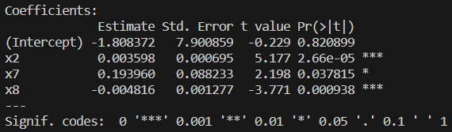

Based on the Pr(>|t|) column (p-value) being <0.05 for each regressor (except for $β_{0}$), we can reject the null hypotheses and conclude that each regressor contributes significantly to the model given that each of the other regressors is included in the model.

$R^{2}=0.7863, { R}_{Adj}^{2}=0.7596$

1. $F_{7}=47.918$; according to the book, $F_{7}=t_{7}^{2}$, however, this is not the relationship that I am seeing. I am not sure how to explain it. It seems to be true of x2 and x8, but .
2. 

Based on the p-value of the F-statistic being <0.05, we can reject the null hypothesis and conclude that at least one of the regressors contributes significantly to the model.

1. 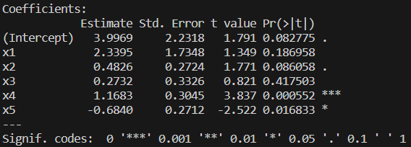

Based on the Pr(>|t|) column (p-value), we see that only aroma (x2), flavor (x4), and oakiness (x5) are <0.05, meaning that we can only reject the following null hypotheses: $β_{2}=0, β_{4}=0, and β_{5}=0$. There is enough evidence to determine that the aforementioned regressors contribute significantly to the model, given that the other regressors are included in the model.

1. For the model including all the regressors: $R^{2}=0.7206, R_{adj}^{2}=0.6769$

For the model only including aroma and flavor: $R^{2}=0.6586, R_{adj}^{2}=0.639$

We already knew that R2 would decrease if the model included fewer regressors. However, the fact that Radj2 also decreased indicates that the model including all of the possible regressors is superior to the model including only aroma and flavor.

1. For the model including all the regressors: $0.548≤β_{4}≤1.789$

For the model including only aroma and flavor: $0.580≤β_{4}≤1.760$

The confidence interval in the model including only aroma and flavor is narrower, suggesting that this model’s estimate for $β_{4}$ is more precise.

1. First you would set up your **T** matrix, your $β$ vector, and your **c** vector to test:

$$H_{0}: Tβ=c, H_{1}: Tβ≠c$$

$$\begin{matrix}T=\left[\begin{matrix}0 & 1 & 0 & 0 & 0 \\ 0 & 0 & 1 & 0 & 0 \\ 0 & 0 & 0 & 1 & 0 \\ 0 & 0 & 0 & 0 & 1\end{matrix}\right] & β=\left[\begin{matrix}β_{0} \\ β_{1} \\ β_{2} \\ β_{3} \\ β_{4}\end{matrix}\right] & c=\left[\begin{matrix}β \\ β \\ β \\ β\end{matrix}\right]\end{matrix}$$

Then you calculate your F statistic using:

$$F_{0}=\frac{{\left(T\hat{β}-c\right)}^{'}{\left[T{\left(X^{'}X\right)}^{-1}T^{'}\right]}^{-1}(T\hat{β}-c)/r}{\left(y^{'}y-{\hat{β}}^{'}X^{'}y\right)/(n-p)}$$

where **X, y**, n, and p are determined from your full model (n is the number of observations, p is the number of regressors + 1).

If $F_{0}>F_{α,r,n-p}$ (where r is the number of independent equations being tested in the hypothesis), we reject the null hypothesis and conclude that at least one regressor out of $β_{1}, β_{2}, β_{3}, β_{4}$ does not equal $β$.

$\begin{matrix}T=\left[\begin{matrix}0 & 1 & -1 & 0 & 0 \\ 0 & 0 & 0 & 1 & -1\end{matrix}\right] & β=\left[\begin{matrix}β_{0} \\ β_{1} \\ β_{2} \\ β_{3} \\ β_{4}\end{matrix}\right] & c=\left[\begin{matrix}0 \\ 0\end{matrix}\right]\end{matrix}$

$$F_{0}=\frac{{\left(T\hat{β}-c\right)}^{'}{\left[T{\left(X^{'}X\right)}^{-1}T^{'}\right]}^{-1}(T\hat{β}-c)/r}{\left(y^{'}y-{\hat{β}}^{'}X^{'}y\right)/(n-p)}$$

Since $c=\left[\begin{matrix}0 \\ 0\end{matrix}\right]$:

$$F_{0}=\frac{\hat{β}'T'{\left[T{\left(X^{'}X\right)}^{-1}T^{'}\right]}^{-1}T\hat{β}/r}{\left(y^{'}y-{\hat{β}}^{'}X^{'}y\right)/(n-p)}$$

If $F_{0}>F_{α,r,n-p}$, we reject the null hypothesis and conclude that either $β_{1}≠β_{2}$ or $β_{3}≠β_{4}$.

Both of these examples could be solved with the help of R using glh.test.